**FYP Final Report**

**Easy Bazaar - Online Marketplace**

Final Year Project Report

by

**Ghayour Haider**

**Yogesh**

In Partial Fulfillment

Of the Requirements for the degree

Bachelor of Science (CS/SE)

Sukkur IBA University,

Sukkur, Sindh Pakistan

(2021)

**Easy Bazaar**

by

**Ghayour Haider & Yogesh**

SUBMITTED TO THE DEPARTMENT OF COMPUTER SCIENCE IN PARTIAL FULFILLMENT OF THE REQUIREMENTS FOR THE DEGREE OF

**BACHELOR OF SCIENCE IN COMPUTERR SCIENCE / SOFTWARE ENGINEERING**

at the

SUKKUR IBA University

**October 2021**

**© 2021 Ghayour Haider & Yogesh** All rights reserved.

The author hereby grants permission to Sukkur IBA to reproduce and distribute publicly paper and electronic copies of this thesis and grant others the right to do so.

Signature of Author(s)

**Ghayour Haider and Yogesh**

Certified by: Internal Examiner

External Examiner

Accepted by:

**DECLARATION**

“We hereby declare that this project report entitled **“Easy Bazaar”** submitted to the “Computer Science”, is a record of an original work done by us under the guidance of Supervisor Mr. Khalid Hussain, and that no part has been plagiarized without citations. Also, this project work is submitted in the partial fulfillment of the requirements for the degree of Bachelor of Computer Science.”

|  |  |  |
| --- | --- | --- |
| **Team Members** | **Signature** | |
| Ghayour Haider | | _____________________ |
| Yogesh | | _____________________ |
| **Supervisor:** | | **Signature** |
| Mr. Khalid Hussain | | _____________________ |
| **Date:** ______________ | |  |
| **Place:** ______________ | |  |
|  | |  |
|  | |  |
|  | |  |

**DEDICATION**

*We dedicate this work to our parents who brought us from heaven to earth and our teachers who taught us to fly to the heavens. Above all, especially thank our FYP supervisor****, Mr. Khalid Hussain****, who remained a constant source of guidance for us throughout the process of our work.*

Table of Contents

Table of Figures 8

ABSTRACT 9

1. INTRODUCTION AND BACKGROUD 10

2. PROBLEM IDENTIFICATION 11

2.1. Quality 11

2.2. Customers’ Trust deficit 11

2.3. Logistics Challenges 11

2.4. Language Barrier 11

2.5. TARGET CUSTOMERS 11

3. LITERATURE REVIEW 12

3.1.1. Quality Improvement 12

3.1.2. Customers’ Trust boosting 12

3.1.3. Logistics Challenges 12

3.1.4. Language Barrier 12

4. METHODOLOGY 14

4.1. Overview 14

4.2. Development Approach 14

4.2.1. Agile 14

4.3. Tools and Technologies 14

4.3.1. Backend Technologies 14

4.3.2. Frontend Technologies 14

4.3.3. Tools 14

5. DETAILED DESIGN AND ARCHITECTURE 15

1. System Architecture 15

2. Architecture Design Diagram 16

3. Entity Relationship Diagram (ERD) 17

4. Class Diagram 18

5. Sequence Diagrams 19

5.1. Sequence Diagram for Shipper mobile application 19

5.2. Sequence Diagram for Easy Bazaar Website 20

5.2.1. Seller Sequence Diagram 20

5.2.2. Buying the Product Sequence Diagram 21

6. Functional Requirements 22

6.1. Functional Hierarchy 22

6.2. Use Cases 22

6.2.1. Shipper’s Use Case Diagram 24

6.2.2. Website Use Case Diagram 25

6.2.3. Seller Use Case Diagram 26

7. Non-functional Requirements 26

7.1. Performance Requirements 26

Safety Requirements 27

7.2. Security Requirements 27

7.3. User Documentation 27

8. IMPLEMENTATION AND TESTING 28

8.1. System Implementation 28

8.1.1. Website 28

8.1.2. Spring Framework 28

8.2. Mobile App Development 29

8.3. Flutter 29

8.4. Database 29

8.5. MySQL 29

8.6. Backend Implementation Details 30

8.7. Working Endpoints for Front End Application 30

8.8. Front End Design Implementation Details 32

8.8.1. Website Sign Up 32

8.8.2. Website Sign In 32

8.8.3. Home Page of the website 33

8.8.4. Shipper Mobile App 34

8.8.4.1. Mobile App login and Google Map Screen 34

8.8.4.2. Mobile App login and Google Map Screen 35

9. RESULTS AND DISCUSSION 36

9.1. API definitions and Description 36

9.1.1. API Seller Sign Up 36

9.1.2. Edit Seller Info 36

9.1.3. List of All Sellers API 36

9.1.4. Add Product API 37

9.1.5. Edit Product Information API 37

9.1.6. All Products of a Seller API 38

9.1.7. Customer Sign Up API 38

9.1.8. Customer Information Update API 39

9.1.9. Purchase Product API 39

9.1.10. Adding Product Pictures API 41

10. CONCLUSION 42

11. Limitations and Future Work 42

REFERENCES 43

# Table of Figures

Figure 1 Statistics of E-banking in Pakistan 9

Figure 2 Flow of Transaction 12

Figure 3 High level front and backend Architecture 14

Figure 4 System Architecture Design 15

Figure 5 ERD Diagram 16

Figure 6 Class Diagram 17

Figure 7 Shipper's Sequence Diagram 18

Figure 8 Seller Sequence Diagram 19

Figure 9 Customer Sequence Diagram 20

Figure 10: Functional Hierarchy of the components 21

Figure 11 Shipper’s Use Case Diagram 23

Figure 12 Website Use Case Diagram 24

Figure 13 Seller Use Case Diagram 25

Figure 14 Website Modules 27

Figure 15 Mobile App Modules 28

Figure 16 Database Design and Implementation Phases 29

# ABSTRACT

E-commerce is fast growing in Pakistan especially with outbreak of COVID-19. More businesses are taking their businesses to online marketplace. However, e-commerce in Pakistan has often found people divided, which stems from the lack of trust the wide majority has in online shopping. While another challenge for e-commerce is the cumbersome process of shipment and delivery due to which sellers avoid taking their businesses online. In addition, leading e-commerce platforms are exclusive in nature due to providing services only in English language while neglecting the fact that majority of population speak and understand Urdu language. In order to improve trust and quality factor between seller and buyer, we propose an idea of online business marketplace where we will connect buyer and seller through our online platform. In our online marketplace the seller and buyer will have no direct connection rather they communicate through our platform. Our platform will play the of role third body where seller and buyer will be facilitated to provide them convenient and reliable environment. In addition, to make sell and purchase easy, our platform will provide online shipment facility to sellers and buyers. The sellers don’t need to go to the courier service to book the consignment and buyers to return the purchased item rather our shippers will pick them up at doorstep within 24 hours. Moreover, keeping the demographic facts in view, the proposed platform will be able to have two languages Urdu and English which will create inclusive online market environment and widen the customer net.

# INTRODUCTION AND BACKGROUD

E-commerce is increasing the output every passing year and is trending all over the world. E-Commerce in Pakistan is at a developing stage with modest internet retail sales. However, it is an emerging sector with a noticeable surge in recent past in online vendors, local e-Commerce platforms and online payment facilities introduced by banks and facilitated/ enabled by cellular companies through their nationwide networks. Pakistan is also a leader in mobile banking transactions in South Asia with a domestic e-Commerce size of almost Rs.100 billion in 2018 [1].

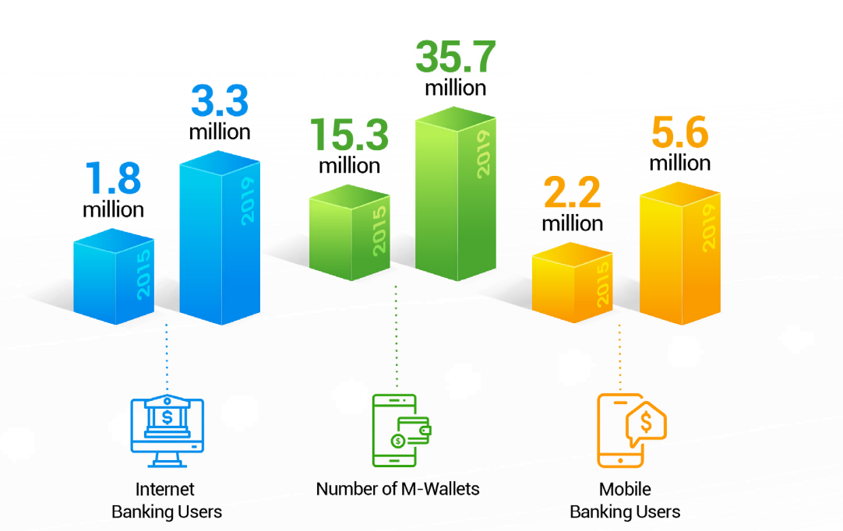

Figure 1 Statistics of E-banking in Pakistan

Source: SBP

In addition, since small and medium sized businesses form a major part of the developing economies, E-commerce has great potential of growth at both state and individual level. Pakistan’s economy is no different [2]. In Pakistan, with the penetration of the internet, more businesses are taking their business online [3].

However, on the other hand in offline shopping, costumer need to move personally to every store to shop items, whereas online shopping is rather easy and comfortable mode of shopping for anybody. There are certain things that made online shopping more convenient these are easy access, save time and manpower, no transport problem and most important is its 24/7 availability [2, 4].

# PROBLEM IDENTIFICATION

Moreover, E-commerce in developing economies is facing some potential challenges. In Pakistan, E-commerce has many challenges to cope with. Literature shows that E-commerce in Pakistan is facing some of the potential following challenges.

## Quality

In Pakistan, customers face quality issues in online shopping. They get fake products when they order online. This, is mainly due to the seller abusiveness in the online marketplace and low check from the existing online markets operating in the country [5].

## Customers’ Trust deficit

Another challenge to e-commerce is the lack of trust of the customer in online shopping due quality and cumbersome return processes in case they want to get their products returned

[2, 6].

## Logistics Challenges

Logistics is another challenge for E-commerce to cope with. Logistics coverage of the logistics companies in the country is limited and they charge heavily if the consignment to ship to the far lung areas. Moreover, they charge more for cash-on-delivery (CoD) method for higher supply chain complexity and a safety risk in CoD [2, 5, 7].

## Language Barrier

Finally, the existing online marketplace platform are exclusive in nature. They have neglected the demographic factors of the country as Pakistan has very low literacy rate. Owing to this, majority of the population don’t understand English, and they cannot use the online marketplace for selling and buying. There is no any other online marketplace platform in native languages specifically in Urdu [5].

## TARGET CUSTOMERS

Our targeted potential customers are businesses with no online sales. Our inclusive online marketplace will enable and encourage them to take their business online.

# LITERATURE REVIEW

Literature shows many online marketplaces are operating globally. These marketplaces include Amazon, eBay, Jumia and Alibaba. Globally, more than 50% of ecommerce sales were made through online marketplaces in 2019, contributing $1.7 trillion to the economy each year [8].

Similarly, Flipkart is an E-commerce company based in Bengaluru, India. Flipkart has launched its own product range under the name "DigiFlip" with including tablets, USBs, and laptop bags. As of April 2017, the company was valued at $11.6 billion. Flipkart is World’s top 10 most visited E-commerce website in India with regards traffic. Multiple Payment method is available for its customers to make Payment easier. It is fastest growing e-commerce website in India. It sells 30 product per min [9].

In Pakistan, Daraz.pk, is the pioneering and leading e-commerce platform started in 2012 as an online fashion retailer and evolved into a general marketplace for brands selling items ranging from electronics to home appliances to fashion [5]. Later, Daraz.pk shifted its business model to operate as online marketplace. Which provides the platform for the vendors to take their business online. The vendors set up their virtual stores on the platform and sell their products. Although, it is the giant online marketplace platform in the country; still it has the above-mentioned challenges to meet [5, 10].

Apart from Daraz.pk there no other big online marketplace to offer such services. However, Amazon is the international online marketplace.

* 1. **PROJECT GOAL**

The aim of the project is to improve the online shopping experience for the customers and sellers by solving issues as mentioned earlier. The Figure 2 shows the step-by-step activities for each transaction.

## Quality Improvement

To improve the quality of the products being sold we propose the following strategy:

1. Assurance of rapid return of the product through easy technical process
2. Penalty on seller for abusiveness

## Customers’ Trust boosting

To boost the customers’ trust in online shopping we propose the following strategy:

1. Product returns within 24 hours
2. Money is deposited back into customer’s account in case of return
3. Rapid return of the money

## Logistics Challenges

To tackle the logistics challenges, we propose the following logistics service:

1. Easiness for seller and buyer
2. Digital payment through E-wallet

## Language Barrier

1. Urdu language integration
2. Easy sale in native language
3. Inclusive platform

The proposed business model will solve all the potential issues and challenges mentioned in the problem Identification section.

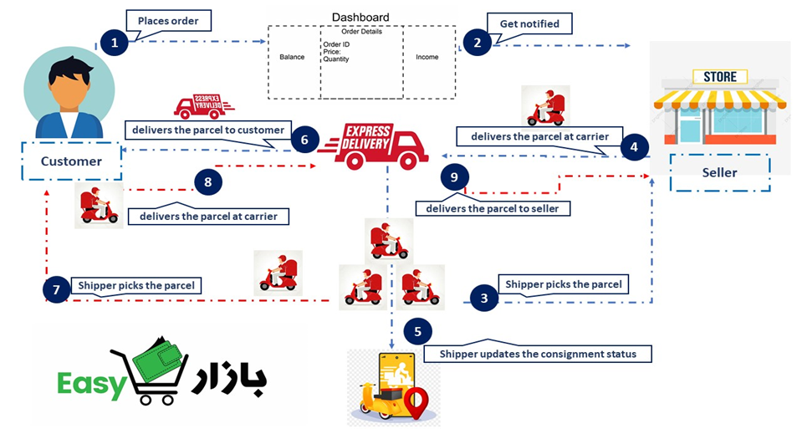

Figure 2 Flow of Transaction

# METHODOLOGY

## Overview

This section describes the Software Development Methodology being used by us, while executing the system. It further identifies the development strategy, approach and tools.

## Development Approach

Easy Bazaar, an online marketplace has been developed by adapting the agile mindset. The website has been broken-down into sub-systems for the ease of development. Agile methodology enabled a way to fast-track the development of the system.

## Agile

Agile is a structured and iterative approach to project management and product development. On this system of approaches, flexible project management methodologies (such a Scrum) are built.

In order to implement this approach, Scrum was used to manage the project. Following activities were performed in the scrum

**Agile Sprint:** This strategy was used to plan and execute the certain modules of the system under development. Code and approach were reviewed after each iteration.

**Daily Scrum meeting:** Meetings were held among groupmates to plan and discuss the system under development. Plan of action for the next day was decided in every meeting.

## Tools and Technologies

## Backend Technologies

The backend of the website has been developed using following technologies

1. Java-Spring-boot framework
2. MYSQL Database

## Frontend Technologies

The frontend of the website and mobile app has been developed using following technologies.

1. React Js
2. Flutter

## Tools

Following tools were used during development of the system

1. IntelliJ IDE
2. VS CODE IDE
3. Android Studio
4. POSTMAN
5. MYSQL Workbench
6. Trello
7. UML & Draw.io

# DETAILED DESIGN AND ARCHITECTURE

This section provides a high-level overview of the system architecture. It defines how the functionality and responsibilities of the system ware partitioned and then assigned to subsystems.

# System Architecture

Architecture of Easy Bazaar has been partitioned into three parts.

1. Centralized Database
2. Website
3. Shipper’s Mobile App

Centralized database has been designed for both website and shipper’s mobile app. Moreover, to provide services to both, RESTFUL service has been created. Created REST APIs for accessing the database or communicating between the server.

For website, REST APIs are created to expose the services of the backend. The web system has been categorized into following sub-modules which are further divided into sub systems.

1. Seller Dashboard
   1. Shop Management
   2. E-wallet module
   3. Profile
2. Customer Dashboard
   1. Profile
   2. E-wallet module
   3. Shopping cart
3. Admin Dashboard
   1. Seller Management
   2. Customer Management
   3. Diagram

      Description automatically generatedShipper Management

Figure 3 High level front and backend Architecture

For shipper’s mobile app, centralized database has been used. Mobile app has been divided into following sub-systems

1. Order Management
2. E-wallet Module
3. Profile
4. Live Location

# Architecture Design Diagram

Following is the diagrammatic representation of the complete system architecture.

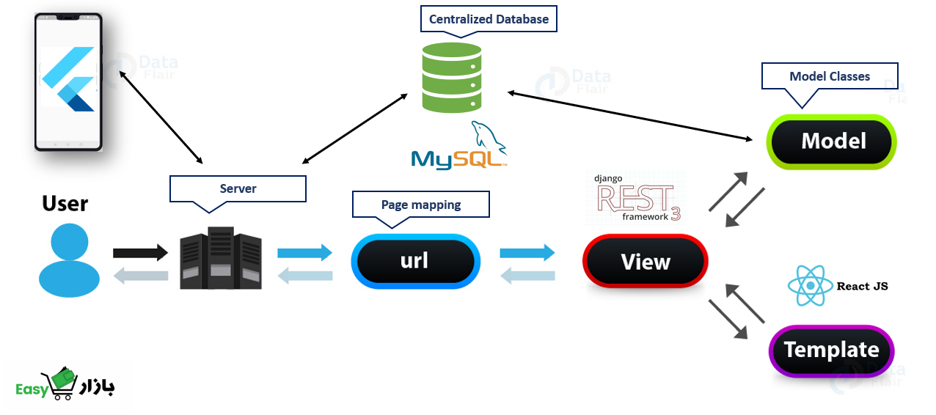

Figure 4 System Architecture Design

# Entity Relationship Diagram (ERD)

Entity Relation diagram defines the logical view of the system. It defines how the entities and their relations will translate into database schema and how the backend of our system will be implemented on the basis of that translated schema.

Figure 5 ERD Diagram

# Class Diagram

Class diagram defines the implementation perspective of system where these classes along with these relations will be coded in respective technology.

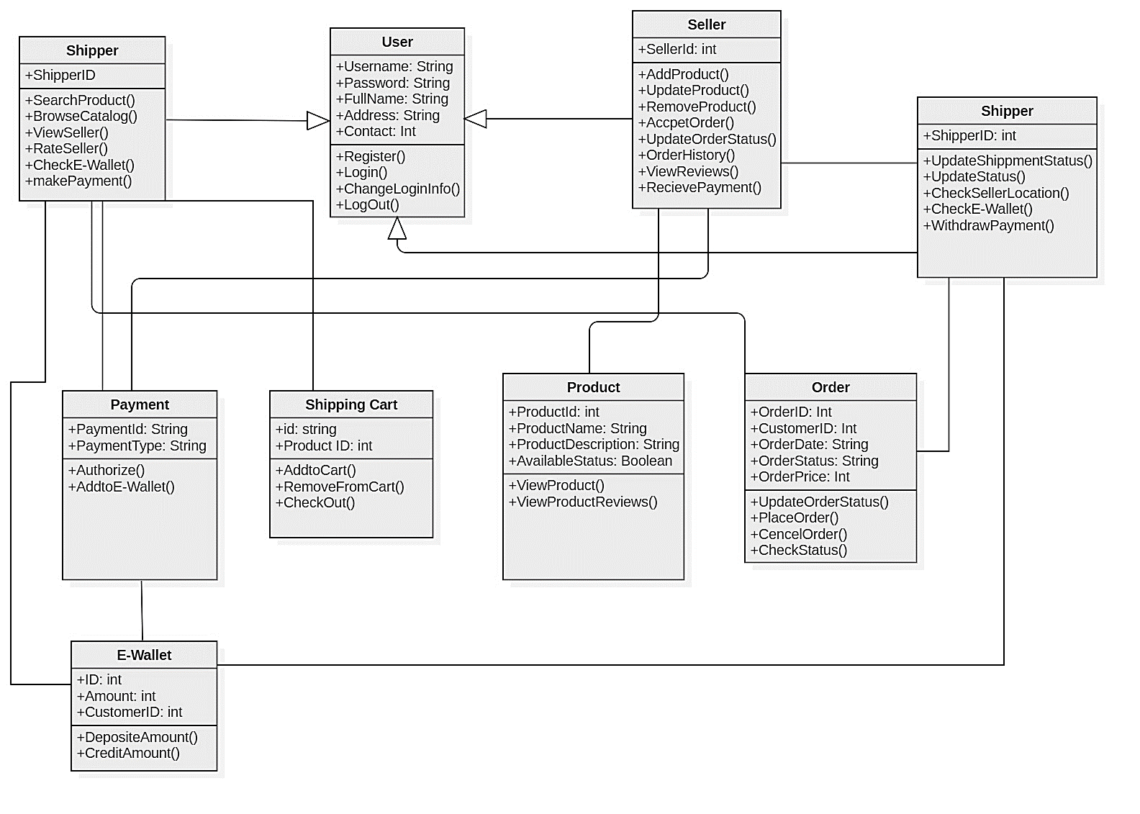

Figure 6 Class Diagram

# Sequence Diagrams

## Sequence Diagram for Shipper mobile application

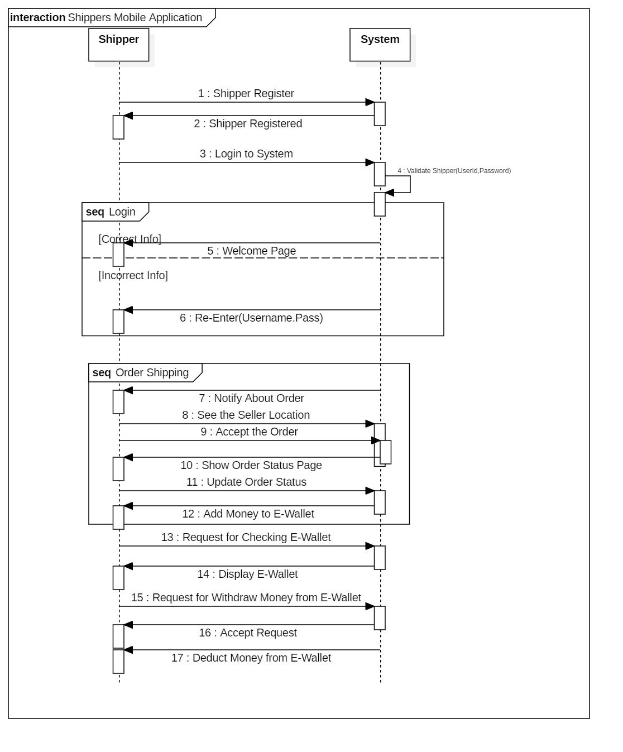

Figure 7 Shipper's Sequence Diagram

## Sequence Diagram for Easy Bazaar Website

## Seller Sequence Diagram

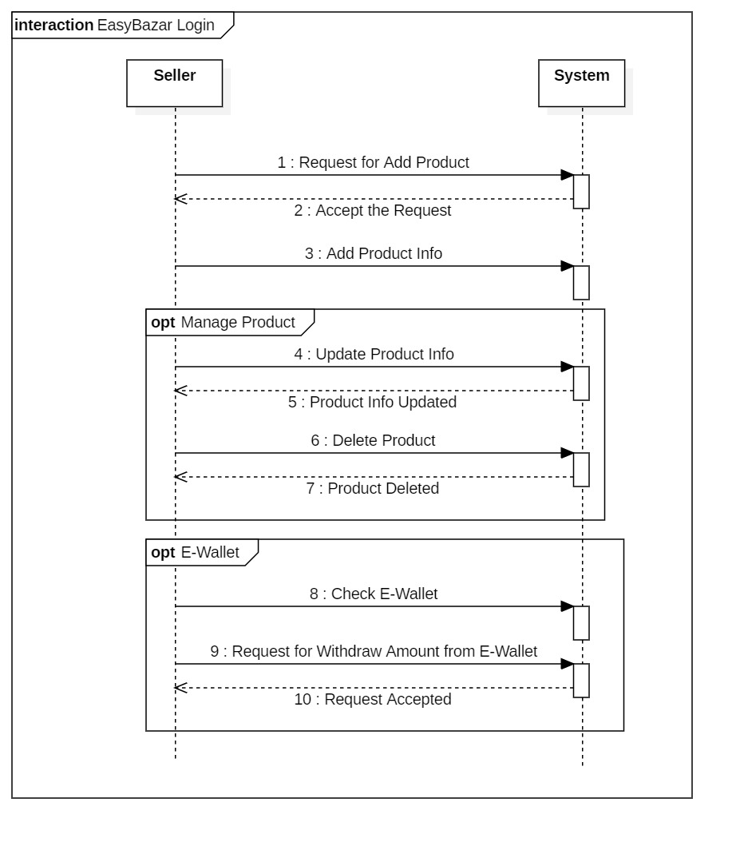

Figure 8 Seller Sequence Diagram

## Buying the Product Sequence Diagram

Figure 9 Customer Sequence Diagram

# Functional Requirements

This section specifies all the functional requirements which specify all basic functions of the system.

# Functional Hierarchy

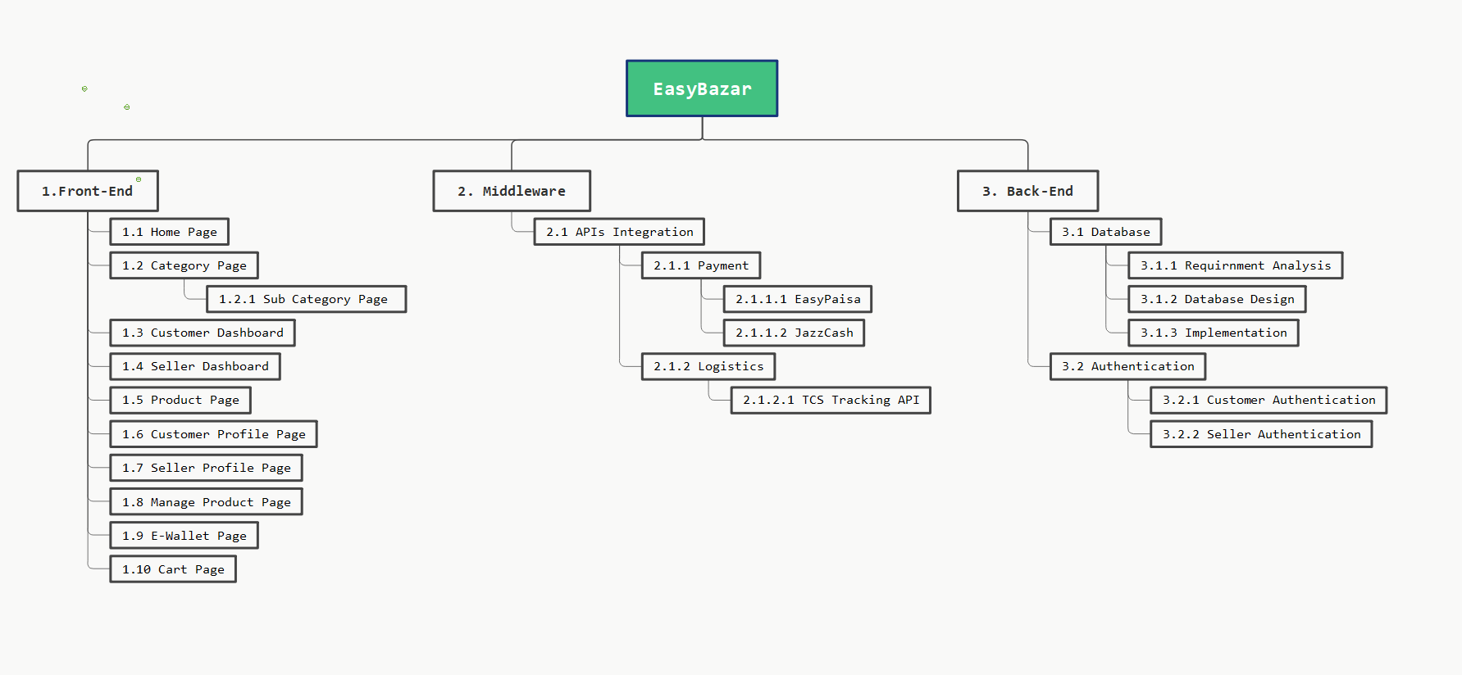

Figure 10: Functional Hierarchy of the components

# Use Cases

There will be three primary actors of the system. Uses cases for each actor are as below

|  |  |  |
| --- | --- | --- |
| **S No** | **Primary Actor** | **Use Cases** |
| 1 | Shipper | Signup |
| Login |
| Check seller’s location |
| Ship consignment |
| Update profile status |
| Check wallet |
| Transfer money |
| Deposit money |
|  |
| 2 | Seller | Signup |
| Login |
| Manage products |
| Process order |
| Check order history |
| View reviews |
| Transfer money |
| Check E-wallet |
|  |
| 3 | Customer | Signup |
| Login |
| Browse catalogue |
| Search seller |
| Make purchase |
| Check wallet |
| Deposit money |

# Shipper’s Use Case Diagram

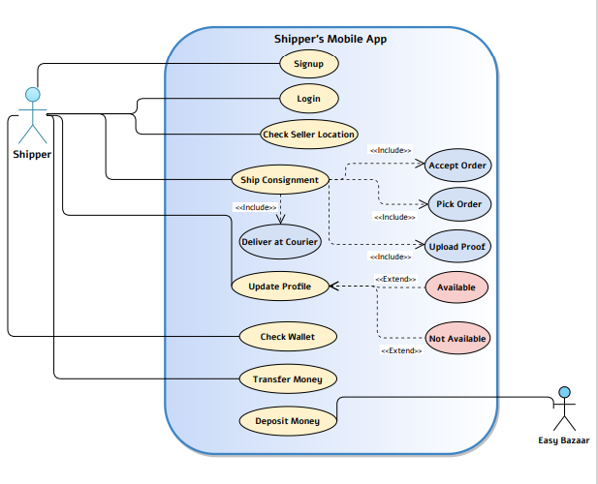

Figure 11 Shipper’s Use Case Diagram

# Website Use Case Diagram

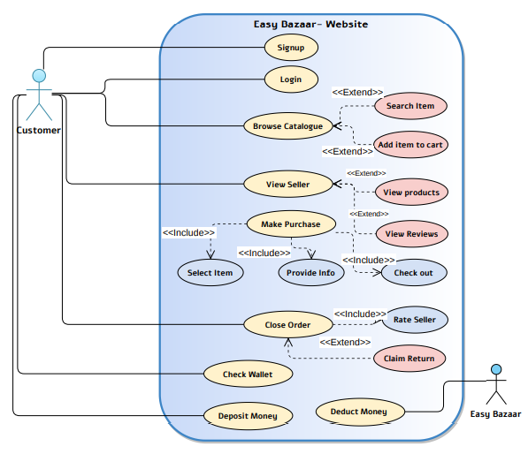

Figure 12 Website Use Case Diagram

# Seller Use Case Diagram

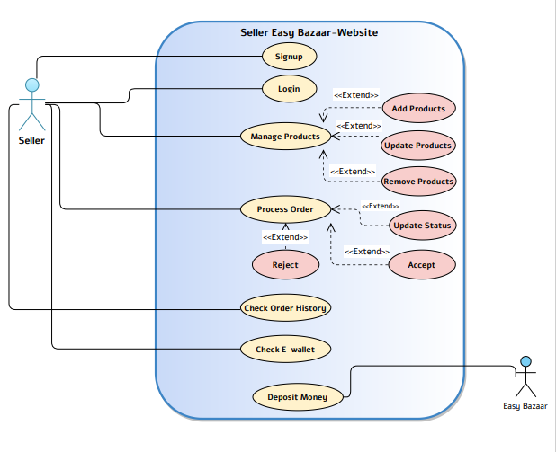

Figure 13 Seller Use Case Diagram

# Non-functional Requirements

This section outlines the fundamental non-functional requirements.

# Performance Requirements

The requirements in this section provide a detailed specification of the user interaction with the software and measurements placed on the system performance.

**NFR-01:**Website MUST be loaded within 05 seconds

**NFR-02*:*** Website MUST display message against actions which will take longer than usual time

**NFR-03:**Website MUST show user understandable messages in case of an error.

**NFR-04:**CRUD operations MUST be performed in less than 2 seconds

**NFR-05:**Website MUST be compatible with different devices and screens

**NFR-06:**Website MUST provide accurate path to other tabs and functions

# Safety Requirements

**NFR-07:**The system MUST not crash while being used

**NFR-08:**Exceptions which may result in data loss MUST be handled

**NFR-09:**System MUST be able to prevent the SQL injection

**NFR-10:**The system MUST have database backup

# Security Requirements

**NFR-11:**SSL MUST installed on server

**NFR-12:**HTTPS should be used

**NFR-13:**Firewall MUST be installed

**NFR-14:** Client-side hashing mechanism MUST be used

**NFR-15:** Website MUST be hosted on secure server

**NFR-16:** Website MUST have two-way authentication mechanism

# User Documentation

*Not applicable yet*

# IMPLEMENTATION AND TESTING

# System Implementation

The system has two parts, the website and mobile app. Details of each part has been giving below.

# Website

For Website development we use Spring boot framework, and the website had the following modules shown in the figure.

Figure 14 Website Modules

# Spring Framework

Spring is one of the most widely used frameworks for developing enterprise applications, providing a robust programming and configuration model. The creation of this framework was facilitated by the desire to simplify the development of applications on the popular Java EE technology stack from Oracle, which was very complex and difficult to use at the time.

Spring has some potential advantages has following:

1. All architectural layers
2. POJO Model
3. Dependency Injection Design pattern
4. Supports various configuration methods
5. Provides middleware-level service.

# Mobile App Development

For Mobile application development we used Flutter framework and the mobile app have the following modules.

Figure 15 Mobile App Modules

# Flutter

Flutter is an open-source UI software development kit created by Google. It is used to develop applications for Android, iOS, Linux, Mac, Windows. To run seamlessly on both iOS and Android platforms Flutter has grabbed its place in the top list of cross platform technologies. Flutter has some potential advantages as following:

1. High Performance
2. Cross Platform
3. Custom Widgets for Quick UI Coding
4. Mild Learning Curve

# Database

We used MySQL database for both Website development and Mobile application development.

# MySQL

MySQL is an open-source relational database management system mostly used in web development. MySQL uses standard SQL language. MySQL is developed and supported by Oracle Corporation. MySQL has some potential advantages as following:

1. Ideal for Small and Large applications
2. Fast and Reliable
3. Compiles on different Platforms
4. Free to Download and Use

Figure 16 Database Design and Implementation Phases

# Backend Implementation Details

This section provides implementation details of the backend services, APIs and overall structure.

# Working Endpoints for Front End Application

Endpoints have been created for the frontend application. Backend provides the following REST endpoints and methods.

1. AUTHORIZATE: '/customer/'
2. LOGIN: '/user/signin/local'
3. SIGNUP: '/user/signup'
4. GOOGLELOGIN: '/user/signin/google'
5. GOOGLELOGINCALLBACK: '/user/signin/google/callback',
6. UPDATEACCOUNT: '/customer/update'
7. UPDATEBILLING: '/customer/update/billing'
8. GETACCOUNT: '/customer/get/account'
9. GETADDRESS: '/customer/get/address'
10. ADDORDERITEM: '/order/add/item'
11. GETORDERLIST: '/order/get/list'
12. GETCART: '/cart/get'
13. ADDCART: '/cart/add'
14. REMOVECART: '/cart/remove'
15. INCREASEQUANTITY: '/cart/increase'
16. DECREASEQUANTITY: '/cart/decrease'
17. CLEARCART: '/cart/clear'
18. GETSHIPPINGMETHOD: '/shippingmethod/get/method'
19. SETSHIPPINGPROCESS: '/shippinginfo/process'
20. GETWISHLIST: '/wishlist/get'
21. ADDWISHLIST: '/wishlist/add'
22. REMOVEWISHLIST: '/wishlist/remove'
23. CLEARWISHLIST: '/wishlist/clear'

# Front End Design Implementation Details

This section provides implementation details of the frontend interfaces and screens.

# Website Sign Up

**

**Welcome to Easy Bazaar**

**Create Your Account**

# Website Sign In

**Welcome to Easy Bazaar**

**Sign Into Your Account**

# Home Page of the website

# Shipper Mobile App

# RESULTS AND DISCUSSION

This section provides overview of the implementation and results. Following are the major module code snippets and results.

# API definitions and Description

# API Seller Sign Up

Sign Up Seller API will take a name, company name, registration date, address, email, password, NIC, city id, password, contact name as a parameter.

# Edit Seller Info

This API will take parameters that are changed by t user like name, password, NIC, etc.

# List of All Sellers API

This API will do not take any parameters. This API will give the list of all sellers’ information with their attributes.

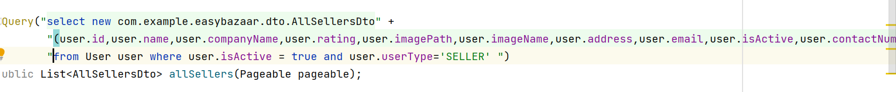

# Add Product API

This API will be used for adding a product by the seller in a store. This API will take all the necessary product information and will take seller id which will tell to whom seller this product belongs.

# Edit Product Information API

This API will take parameters that are updated by the user for a product like a price, name, etc.

# All Products of a Seller API

This API will take the seller id in an API path and will give all the products information against that seller id.

# Customer Sign Up API

Sign Up Customer API will take a name, registration date, address, email, password, NIC, city id, password, contact name as a parameter.

# Customer Information Update API

This API will take parameters that are changed by the customer like name, password, NIC, etc.

# Purchase Product API

This API will take parameters like customer id, shipping address, and list of product ids with their respective quantities.

# Adding Product Pictures API

This API will take an image in a form data and will save the image in a backend folder and will create its path and the path URL will be saved in the database to access the image.

# CONCLUSION

E-commerce is at the nascent stage in Pakistan. It is emerging sector with a noticeable surge in the recent years. ICT infrastructure and affordable internet access has enabled the remote areas to get connected to the mainstream. Small and medium size businesses have growth opportunities to take their businesses online. Easy Bazaar is an online marketplace based on B2C business model. Where we connect businesses to the customers through our platform. Easy Bazaar employs shippers to handle the regional logistics. Shippers pick and drop the products from sellers to our nationwide logistics partners’ regional offices. Easy Bazaar plays the of role third body where seller and buyer will be facilitated to provide them convenient and reliable environment. However, e-commerce in the developing world is facing some potential challenges as well. Likewise, in Pakistan, e-commerce has several potential challenges to cope with. It includes poor quality issues, customers’ trust deficit in the online shopping, logistics issues in delivery, language barriers due to low percentage of the population and especially, local businessmen understand English language.

In order to improve trust and quality factor between seller and buyer, we proposed an idea of online business marketplace where we are connecting buyer and seller through our online platform. In our online marketplace the seller and buyer have no direct connection rather they communicate through our platform. Our platform will play the of role third body where seller and buyer will be facilitated to provide them convenient and reliable environment. In addition, to make sell and purchase easy, our platform provides online shipment facility to sellers and buyers. The sellers don’t need to go to the courier service to book the consignment and buyers to return the purchased item rather our shippers will pick them up at doorstep within 24 hours. Moreover, keeping the demographic facts in view, the proposed platform will be able to have two languages Urdu and English which will create inclusive online market environment and widen the customer net. The idea will prove to be a great contribution to the digital economy of Pakistan.

# Limitations and Future Work

Designing and implementation of the online marketplace is time taking and require a good team to put up the platform. Therefore. Our project has many limitations which need to be mentioned. This is the proof of concept and very first version of the business idea. It is not fully functional platform. In addition, due to non-availability of the payment gateways, we have not integrated any of the payment method however, we are considering Cash-on-Delivery as payment method for now.

Furthermore, due to wide scope of our project, we have included some the functionalities into our future work scope. They will be implemented in the future. Following functionalities are to be considered in the future.

1. Urdu Language Integration
2. Admin Dashboard
3. Integration of Payment Gateways
4. Route suggestion for shipper

# REFERENCES

1. COMMERCE, M.O., *E-Commerce Policy of Pakistan.* 2019.

2. Ahmed, R., *Ecommerce in Pakistan: Challenges & Opportunities.* 2019.

3. Khan, S.H. and M.Z. Arshad, *Why E-Commerce Remains Unsuccessful in Pakistan?* 2010.

4. Nasir, T.A. and M. Abdullah, *Current Trends and Future of E-Commerce in Pakistan.*

5. Jajja, M.S.S. and M.N. Jat, *Daraz. pk: Online Marketplace’s Value Chain.* Asian Journal of Management Cases, 2019. **16**(1): p. 21-37.

6. Ali, S.M. and A. Ishaq, *Prospects and Challenges of Adopting E-Commerce System in Pakistan–An Empirical Research.* International Journal of Computer Applications. **975**: p. 8887.

7. Khan, W.A., et al. *E-commerce in Pakistan: Growth potentials and e-payment solutions*. in *2013 11th International Conference on Frontiers of Information Technology*. 2013. IEEE.

8. Merton, K., *The World’s Top Online Marketplaces 2020.* 2019.

9. Padmanabh, B., *flipkart. com’s Strategy on Amazon. com’s Entry into India: A Case Study.* Ushus Journal of Business Management, 2013. **12**(4): p. 131-143.

10. Ahmed, W., *An Investigation into Customer Preferences for Online Shopping In South Asia (Pakistan): A Case Study of Daraz. pk.* 2020.